(ADD WEBINAR TITLE):
Login Instructions
To join a Zoom webinar you will need to download the Zoom application, have a connection to the Internet, and speakers. Zoom's web-based conferencing uses high-quality video and audio, and is accessible on MacOS, Windows, iOS and Android mobile devices. You should load and test the software on the device and location you will be using for the webinar. To download the Zoom app prior to the webinar and to test your audio, follow the instructions below.

Webinar Details
Title: (ADD TITLE)
Date/Time: (ADD DATE/TIME)
Dial In Phone Number: (ADD PHONE NUMBER FROM ZOOM WEBINAR INSTRUCTIONS)
URL: https://msu.zoom.us/j/(ADD 9 DIGIT NUMBER)
Meeting ID for Joining by Mobile Device: (ADD MEETING ID FOR THOSE JOINING BY MOBILE DEVICE)
Technical Assistance: Michigan State University Help Desk | 800-500-1554 (24/7 support)
If you do not have the application loaded, we recommend you download the Zoom app prior to the webinar and test your audio. Following are instructions for either joining by a computer or mobile device.

Installing Zoom & Testing Your Connection/Audio Using a PC or MAC Computer
- Click on the following link: (ADD YOUR ZOOM WEBINAR URL HERE)
- You will be prompted to download and run the Zoom application (http://msu.zoom.us/download)
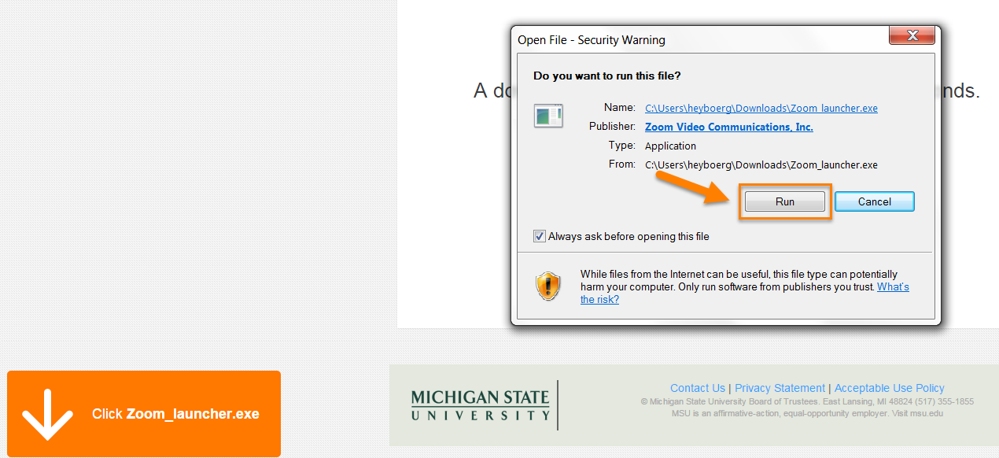

- Once the software installs enter your Email and Name. Click the Join Webinar button.
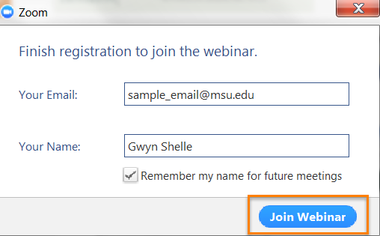
- If you are testing your connection/audio on a PC or MAC prior to the webinar you will see the screen below. Click on the Test My Speaker button to test your audio.
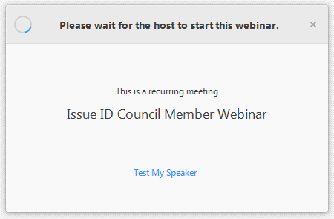
Webinar Title
- Test your audio by clicking on the Test Speaker button. You can adjust your volume level by sliding the volume bar. If you have any difficulty hearing the audio make sure the correct audio device is selected from the drop down menu. When you are done testing your sound close the Settings window.
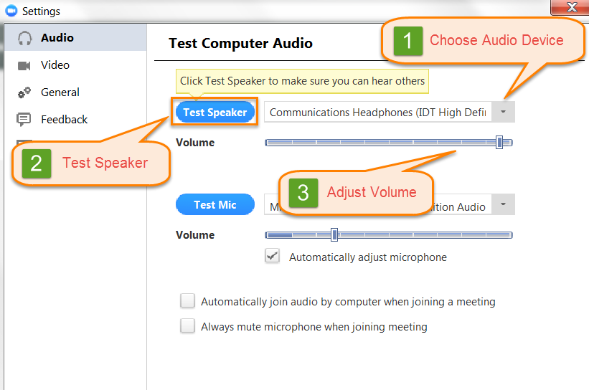
- Once you have tested your speakers, you can exit Zoom. On the day of the event, when the host opens the webinar at the designated time, your screen will likely display a PowerPoint slide or a video of a speaker.

Joining a Zoom Webinar from an iOS or Android Device
- Download the Zoom Cloud Meetings App to your device through iTunes or the Google Play Store.
- Open the application on your mobile device.
- Select Join a Meeting and enter the meeting ID.
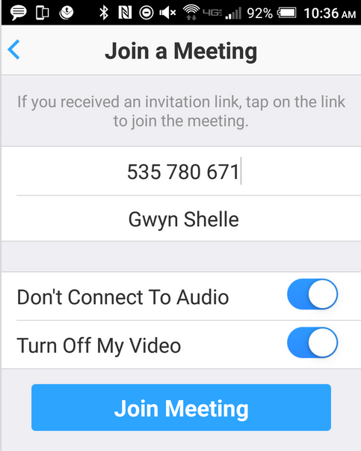
ENTER MEETING ID HERE
- Select the Join Meeting button.

